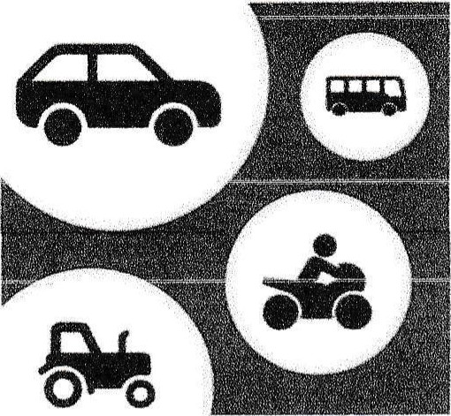
Grasby Motor Show (DN38 6AP)
Entry Form
Saturday 12th September 2026 12 — 4pm with closing parade
(Only road legal vehicles may participate)

Name:
Address:
Contact Number: Email:
CAR MOTORBIKE TRACTOR OTHER (please state)
Make: Model: Engine Size: Reg Number:

Would you be interested in exhibiting at further events: YES NO
All vehicles must be insured, please bring certificate and show, if requested by officials.
Return Form to: Claire Bullass, 30 Staniwells Drive, Broughton, Brigg, DN20
OBD or email grasbymotorshow@gmail.com Telephone / Text: 07896003157
** All vehicles Must be booked in for Best in Show awards ** ** Closing Date Sunday 6th September **
RAISING MONEY FOR LINCOLNSHIRE AND NOTTS AIR AMBULANCE.

DONATIONS WELCOMED

