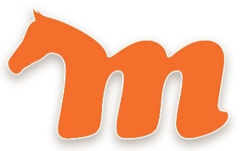
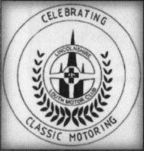
117th MESSINGHAM SHOW
Saturday 8th June 2024 9.45am – 5.30pm
Holme Meadow, Holme Lane, Messingham. DN17 3SG
The annual show includes Show Jumping, Showing, Carriage Driving, Mounted Fancy Dress & Gymhana Games along with WI display/competitions, trade stands, free children’s entertainment, beer tent, band stand, displays, classic cars and live music on the MessFest stage.
Owners of cars or light commercial vehicles (being car derivative or up to 12cwt) are invited to enter vehicles
first registered prior to 2004 into the
Open Classic Car Display
Kindly organised by the Lincolnshire and Louth Motor Club Classics Section and supported by Skyline Internet Ltd.
Free entry for driver and one passenger. Additional passengers £5 payable upon entry.
CONDITIONS OF ENTRY TO DISPLY AREA – NO PASS NO ENTRY
- All entrants MUST comply with the Show Officials directions.
- All vehicles to be in place by 9.45am. No vehicles will be accepted after this time.
- No vehicles are to be moved /or to leave the showground before 5.30pm without the permission of Show Officials. Any vehicles moving on the showground MUST have consent and have an official steward escort.
- No engines may be run whilst Messingham Show is in progress.
- All vehicles MUST comply with the Road Traffic Acts and other relevant legislation, be in a presentable condition and must be over 20 years old.
- Oil drip trays to be used.
- All dogs MUST be kept on a lead and under control at all times.
- Picnics are welcome but no barbeques.
- I understand that the Lincolnshire Louth Motor Club Ltd, or its Officers, and the Organisers of Messingham Show and their representatives will not accept responsibility for any loss, or damage to any persons, or vehicles whilst attending Messingham Show. I agree to comply with the above Conditions of Entry and to comply with the request of any official whilst at Messingham Show.
Please return the application slip below to Jason Wray (07974 612437) – by post to 26 Chapel Road, Broughton, Brigg. DN20 0HW, enclosing a stamped addressed envelope for return of entry pass.
Entries deadline is 14 days prior to the event. No pass – no entry.
In the event that the space is full when your application is received, you will be contacted as soon as possible and advised if spaces become available.

Entry form – Messingham Show on Saturday 8th June 2024
Name __________________________________________________ Tel No _________________________________
Address ________________________________________________________________________________________
________________________________________________________ Email _________________________________
Vehicle Make _____________________________________________Model ________________________________
Year of manufacture _____________Reg ___________________ Membership no (if LLMC member)_____________
Insurance company and policy number________________________________________________________________
I HAVE READ THE CONDITIONS OF ENTRY ABOVE AND AGREE TO BE BOUND BY THEM.
Signed ___________________________________________________ Date _________________________________

